FRONTEND COMPLETE DESIGN (BASIC)
KUNAL GARG
Signup :
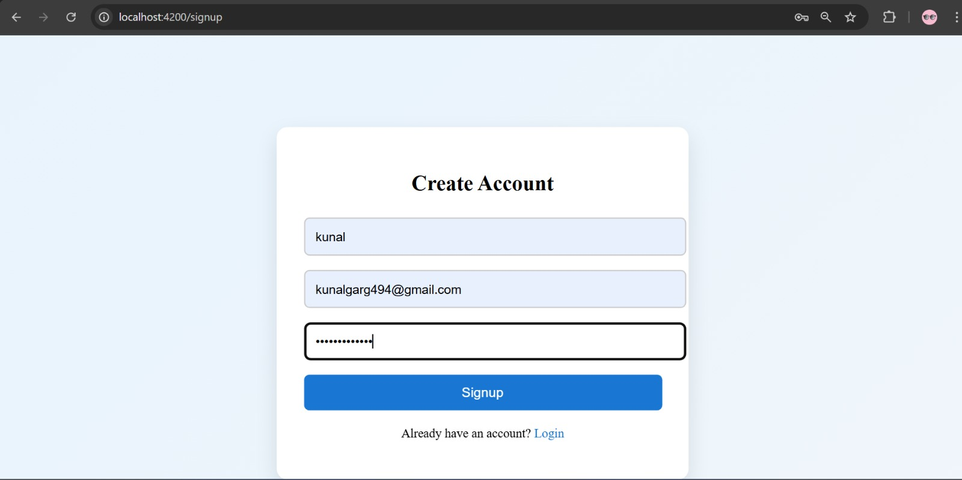

Login :

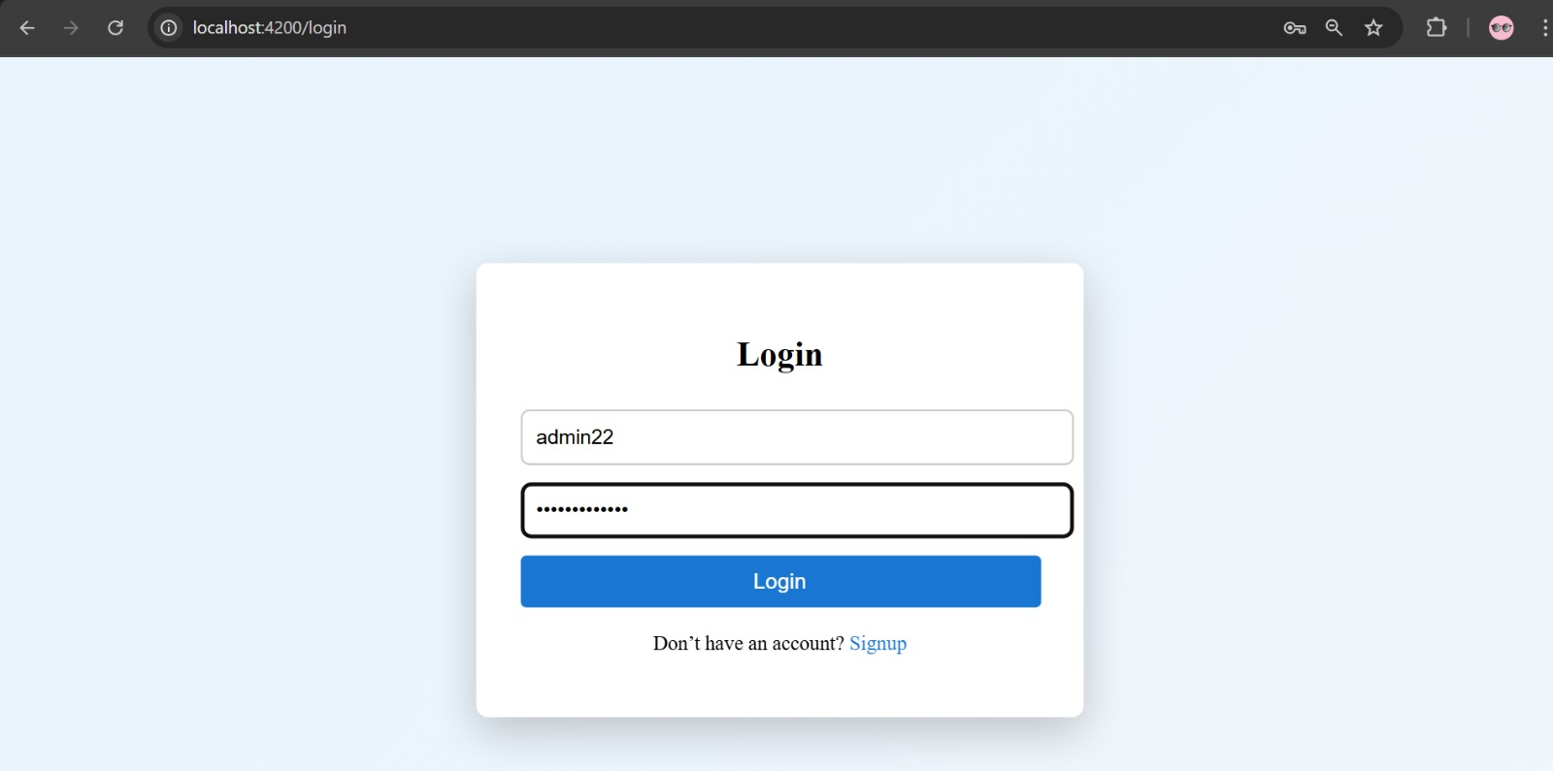

Search Flight :

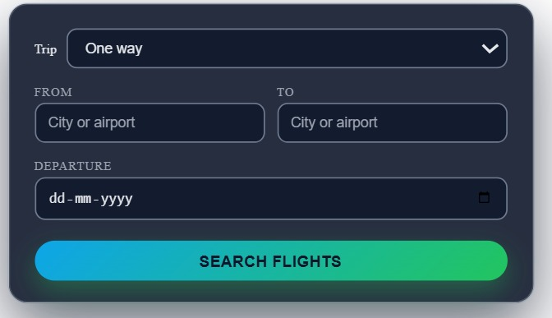

Add Flight (only by Admin):
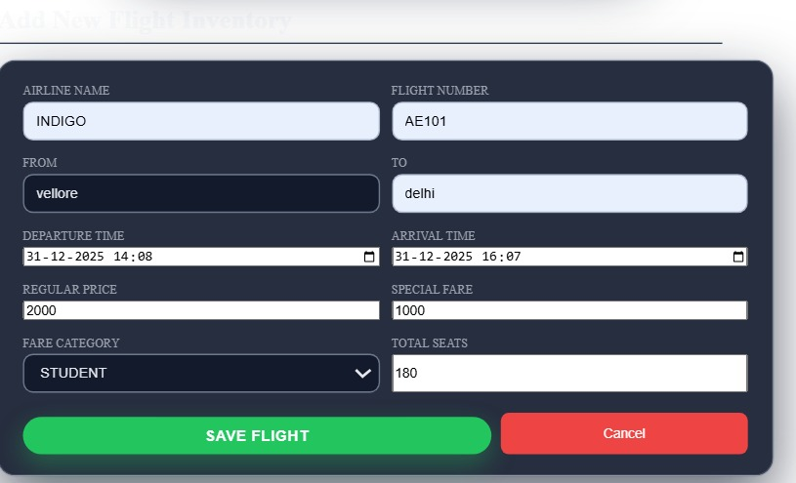
Backend working correctly (Both locally and in docker)
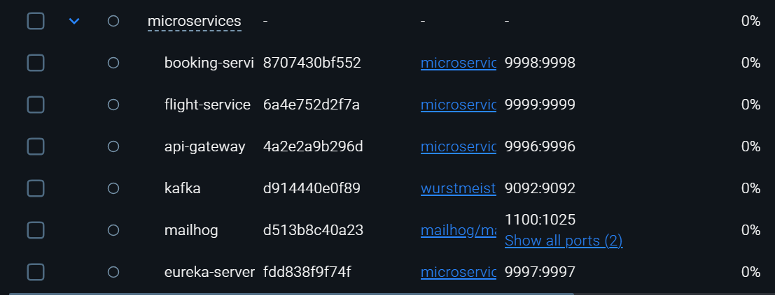
Service-starter.cmd created
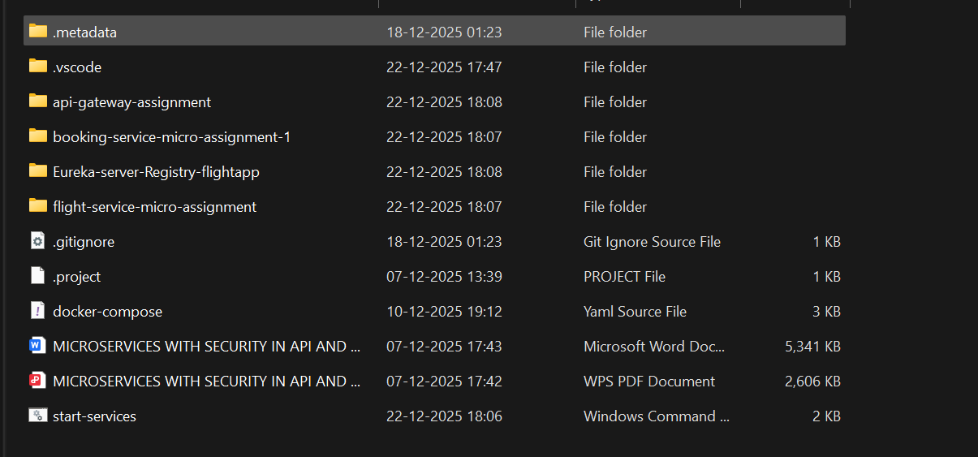
Password -Validations :

https://github.com/Kunalgarg92/microservice_implemented_docker

